# STUDY OF VIRTUAL MACHINE MIGRATION DATE

## AIM:

To study about Virtual machine migration, its need, migration types, techniques, benefits and limitations in detail.

## INTORDUCTION:

The movement of VMs from one resource to another, such as from one physical host to another physical host, or data store to data store, is known as VM migration.

Basically, it is the process of migrate a virtual machine from one host to another. It also has the capability to move workload of multiple running virtual machines on a single physical machine. The main difference between virtualization and virtual machine migration is that only migration module is inculcate with hypervisor. The architecture of virtual machine migration virtualized platform is shown in figure:

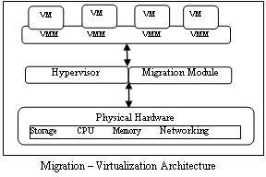

Although, the process of migration has been initiated in 1980, but it was used often-ally, due to its main limitation i.e., how to handle interaction between various modules of operating system. But it overcomes in virtual machine migration because it moves the whole operating system along with running processes. VM migration becomes this process simplified and efficient. It also takes care of load balancing, energy consumption, workload consolidation etc. Henceforth, it becomes more popular and wide adoption in industry. Below table describes the types of VM migrations. **Why is it needed?**

## Load Balancing:

* Move VMs to a less busy host
* Make use of newly added capacity

## Maintainance:

* Move VMs off a host before it is shut down.

## Recovery from Host Failure:

* Restart VM on a different host.

## VM Migration Type: 1.Cold Migration:

Before migration, the virtual machine must be powered off, after doing this task. The old one should be deleted from source host. Moreover, the virtual machine need not to be on shared storage.

## Warm Migration:

Whenever transfer OS and any application, there is no need to suspend the source host. Basically, it has high demand in public cloud.

## Live Migration:

It is the process of moving a running virtual machine without stopping the OS and other applications from source host to destination host.

## Techniques of VM Migration:

It is basically of two types:

1. **Pre- Copy Migration:** In this migration, the hypervisor copies all memory page from source machine to destination machine while the virtual machine is running. It has two phases: Warm- up Phase and stop and copy phase.
   * **Warm Up Phase:** During copying all memory pages from source to destination, some memory pages changed because of source machine CPU is active. All the changed memory paged known as dirty pages. All these dirty pages are required to recopy on destination machine; this phase is called as warm up phase.
   * **Stop & Copy Phase:** Warm up phase is repeated until all the dirty pages recopied on destination machine. This time CPU of source machine is deactivated till all memory pages will transfer another machine. Ultimately at this time CPU of both source and destination is suspended, this is known as down time phase. This is the main thing that has to explore in migration for its optimization.
2. **Post- Copy Migration:** In this technique, VM at the source is suspended to start post copy VM migration. When VM is suspended, execution state of the VM (i.e. CPU state, registers, non- pageable memory) is transferred to the target. In parallel the sources actively send the remaining memory pages of the VM to the target. This process is known as pre-paging. At the target, if the VM tries to access a page that has not been transferred yet, it generates a page fault, also known as network faults. These faults are redirect to the source, which responds with the faulted pages. Due to this, the performance of applications is degrading with number of network faults. To overcome this, pre-paging scheme is used to push pages after the last fault by dynamically using page transmission order. Figure 3 & 4 shows the pre copy and post copy migration technique respectively.

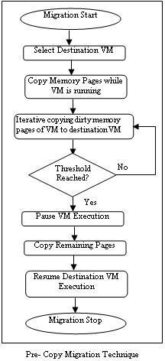

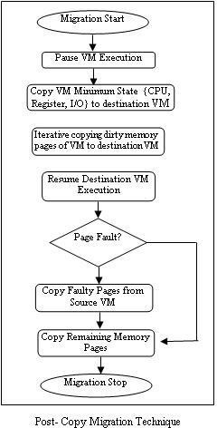

## Benefits of migrating virtual machines:

Migrating virtual machines (VMs) can be useful for

## Load balancing

VMs can be moved to host machines with lower usage if their host becomes overloaded, or if another host is under-utilized.

## Hardware independence

* + When we need to upgrade, add, or remove hardware devices on the host machine, we can safely relocate VMs to other hosts.
  + VMs do not experience any downtime for hardware improvements.

## Energy saving

VMs can be redistributed to other hosts, and the unloaded host systems can thus be powered off to save energy and cut costs during low usage periods.

## Geographic migration

VMs can be moved to another physical location for lower latency or when required for other reasons.

## Limitations for migrating virtual machines:

Before migrating virtual machines (VMs) one must aware of the migration’s limitations.

* + Live storage migration cannot be performed on RHEL 8, but can migrate storage while the VM is powered down.
  + But it is available on Red Hat Virtualization.
  + Migrating VMs from or to a session connection of libvirt is unreliable and therefore not recommended.
  + VMs that use certain features and configurations will not work correctly if migrated, or the migration will fail. Such features include:

1. Device passthrough
2. SR-IOV device assignment
3. Mediated devices, such as vGPUs
4. Non-Uniform Memory Access (NUMA) pinning

## RESULT:

Thus, the study about Virtual machine migration, its need, migration types, techniques, benefits and limitations in detail has been completed successfully.